Computer Networks - Test 2

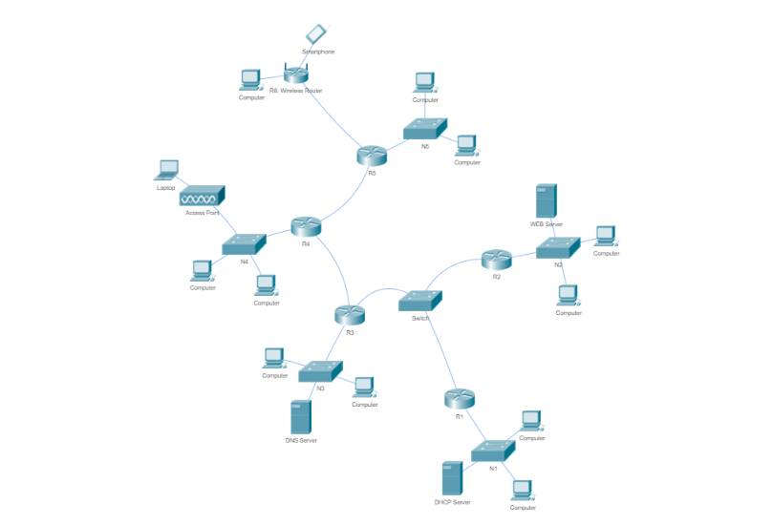

**Network ip:** 202.120.216.0
mask : 255.255.248.0 (/21)

**Subnets:**

* N1: 384 IP's
* N2: 224 IP's
* N3: 128 IP's
* N4: 128 IP's
* N5: 32 IP's

What other networks do you need?

**Questions:**

Use DHCP to assign IPs to your hosts.

Configure static routing.

Configure NAT on a subnetwork.

What's the maximum number of IP's your Network can hold ?